程序代码：

#include<iostream>

using namespace std;

class Complex {

public:

double real, img;

Complex(double r = 0 ,double i = 0)

{

real = r;

img = i;

}

};

Complex operator\*(Complex a, Complex b)

{

Complex temp;

temp.real = a.real \* b.real-a.img\*b.img;

temp.img = a.real \* b.img + a.img \* b.real;

return temp;

}

int main()

{

double x,y,z,i;

cout << "请输入两个复数的实部和虚部:" << endl;

cin >> x >> y >> z >> i;

Complex X(x, y);

Complex Y(z, i);

Complex temp;

temp = X \* Y;

cout << "乘积的实部是: " << temp.real << endl;

cout << "乘积的虚部是: " << temp.img << endl;

return 0;

}

运行结果：

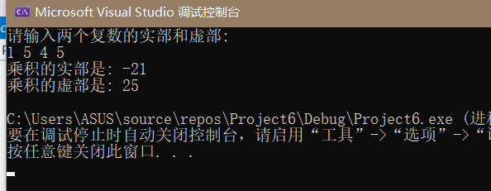

心得：要牢记运算符重载c++中有如下规定：

不允许将+ - \* \ 进行无意义的重载，会造成程序不易阅读的问题；不允许用户重载自定义的运算符；重载不能改变运算符原有的结合性；重载不允许改变运算符的操作对象的个数。

Copyright ©2021-2099 Haotian Wang. All rights reserved